Lecture 5

HTML is not application to application format

We want to reuse business logic

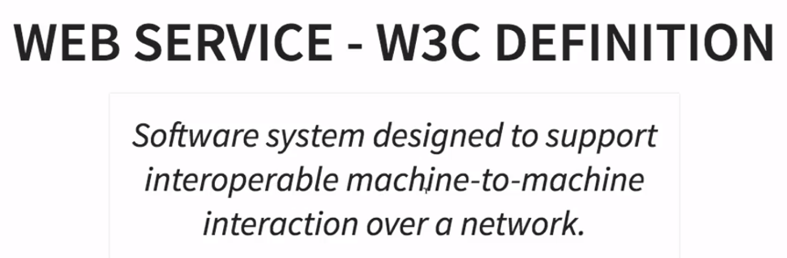

Application to application interaction

The website he made - todos - not a web service

Interoperable - not platform dependent, .NET, PHP, Java

Allow communication over network

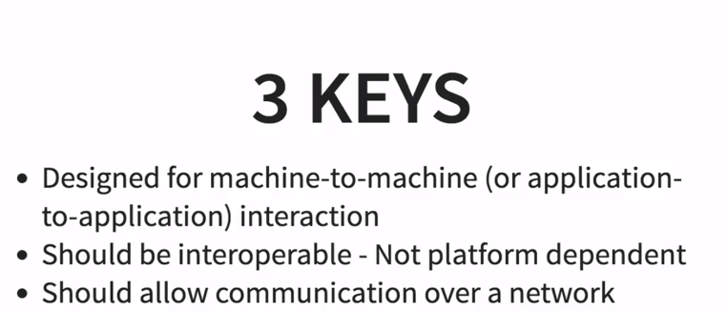

Lecture 6

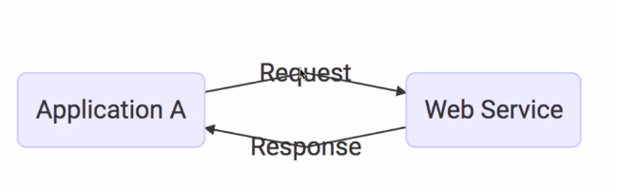

Must be platform independent

Request/Response also must be platform independent

XML or JSON

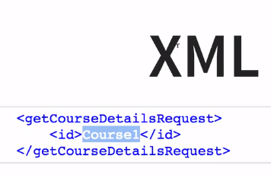

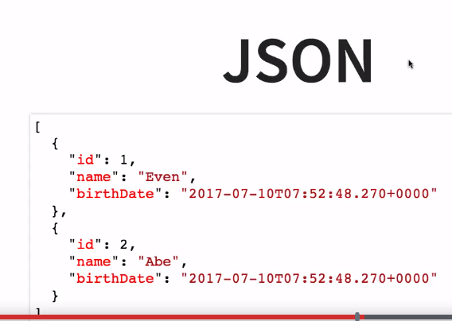

JSON supported on front end and backend systems

Every web service offers a **service definition** - the "contract"

Is it JSON or XML

The format of the request/response

Endpoint - where is the service, where the consumer can call the service

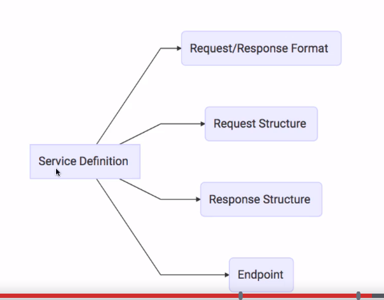

Lecture 7

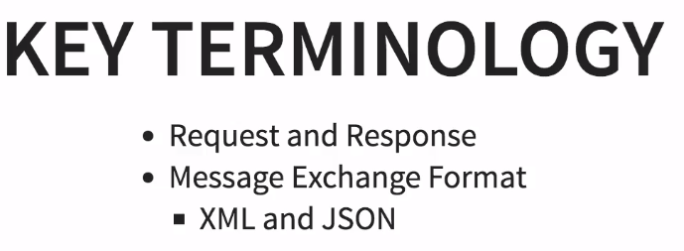

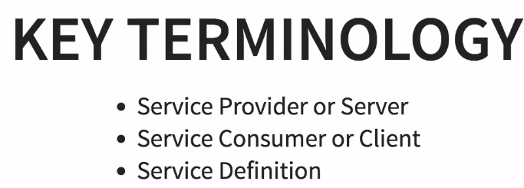

Provider - hosts the web service

Consumer - uses the web service - an application

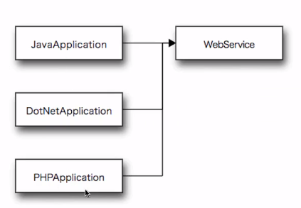



HTTP - over the internet

MQ - communication over a queue - basically the request/response get "picked up" from a queue

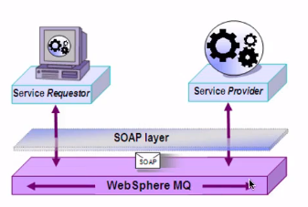

Lecture 8

SOAP - we use XML, defines a specific request/response structure

Need a SOAP envelope, which has a header & body

Header - authentication, authorization, signatures

Body - put the content of your request/response

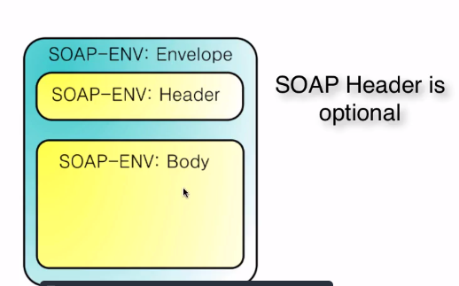

Example Response:

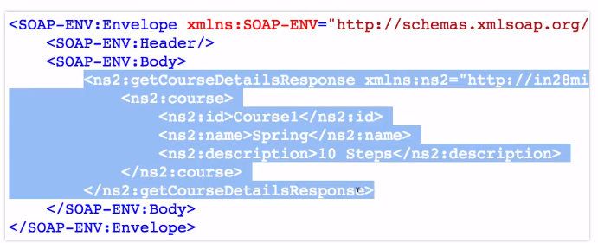

SOAP defines format for request/response

* + But doesn't put restrictions on transport - use HTTP or MQ
  + Service definition done by a "web service definition" - WSDL

WSDL - defines the endpoint - where the service is exposed & what operations are allowed

Lecture 9

REST - representation state transfer

Invented by Roy Fielding - guy that came up with HTTP

So this uses HTTP for web services

RESTful web services try to define services using HTTP concepts

Resource - anything you want to expose to the outside world - anything you can get using the service

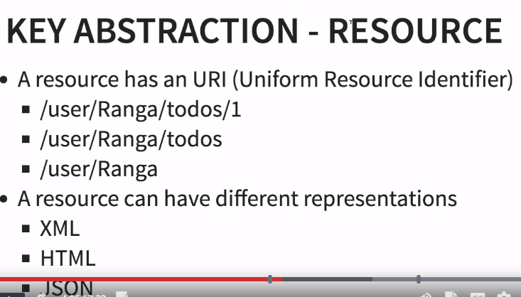

So we assign a URI to the resource

REST doesn't worry about how you represent your resource - can be XML, HTML, JSON - you just need to define your resource & use HTTP verbs

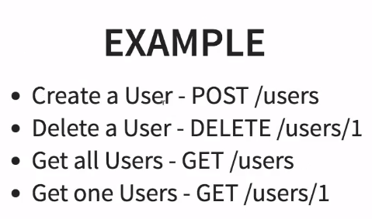

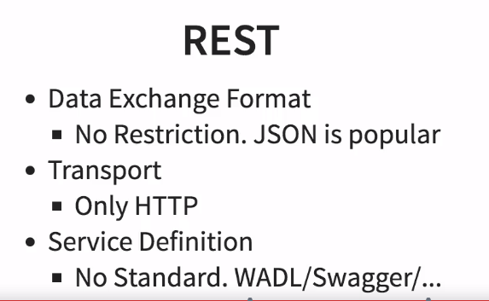

WADL - web application definition language - can specify your RESTful web service - but not very popular

Swagger - an alternative to WADL - gaining popularity

Lecture 10

REST vs. SOAP - not an apples-to-apples comparison

SOAP - uses XML

REST - is an architectural style

Data Exchange Format

SOAP - XML - need to use

REST - no specified format - JSON (most popular), XML

Service Definitions

SOAP - WSDL

REST - WADL or Swagger

Transport Protocol

SOAP - HTTP or MQ

REST - HTTP

REST - usually easier to implement than SOAP

Lecture 11 - Beginning of Spring Framework

Go to Spring in 10 Steps on Github

Lecture 12

Start.spring.io - spring initializer

Src/main/java - where the java code is written

Src/main/resource - application properties

So we got Eclipse set up & imported the project

Lecture 14

Tight coupling & dependency injection

Tightly coupled - A is inside B. If you want to change A, you have to change B - but we just want to change A. Tightly coupled isn't good. You want to implement A outside of B.

And while this is good, let's say you wanted to change A to C - and use it inside B.

We want to be able to switch between A or C dynamically.

I saved the code in a separate folder just for this step

<<L14 Explained.docx>>

Lecture 15

Right now, the BubbleSortAlgorithm is hard code as our choice

The solution is interface

Use control-1 to have the **interface generated for you** - after you have typed out "implements (name of interface")

// L15 - so we have changed binarySearch to use the interface - we're going to pass in what algorithm we want to use

This is how you make your code loosely coupled

You pass into BinarySearchImpl which sort method you want to use

Next - we will bring in Spring

The most important concepts behind Spring are dependency injection and loose coupling.

Lecture 16

Hmm - looks like you can checkout a specific commit from Github - use the number next to the commit

We need a framework to manage the beans and the dependencies

// !!! new QuickSortAlgorithm() is a bean - a instance of an object

// !!! we want to be able to wire it in the dependencies - we want to wire into BinarySearchImpl

??? I think QuickSortAlgorithm is a dependency of BinarySearchImpl here…

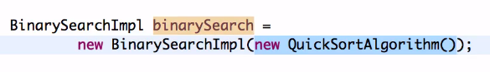

The Spring Framework helps us to manage beans via wiring in the dependencies

What you need to tell Spring

* + What are the beans? **@Component**

@Component indicates this is a bean

* + What are the dependencies of a bean? **@Autowired**  
    BinarySearchImpl.java

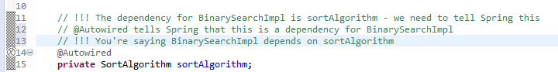

* 1. Where to search for beans?

Find them in this package? Or another one?

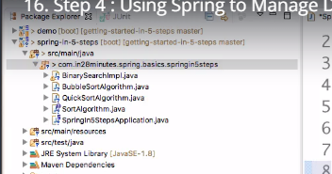



Application Context maintains all the beans - we need to get the bean from the application context

We're making Spring manage our beans, manages dependencies, & injects them where they are needed - this is called dependency management

Lecture 17

Enable debug mode in application.properties

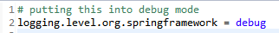

Looking at the logs, you can see a component scan being done - it's looking for @Component - and there are others it searches for

It will then list where if found @Component tags

Then it starts to create the beans

If it sees @Autowired - aka, any dependencies - it knows it has to make the dependency first - before it can make the bean

It may use the constructor to create the bean - called **constructor injection**. There is also something called **setter injection**.



This is how Spring creates beans

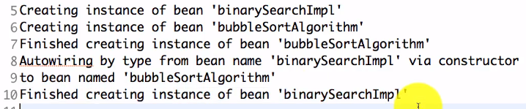

My logs look a little different



Lecture 18

So what if we added a @Component to QuickSortAlgorithm? Then we would have 2 @Components - one for QuickSortAlgorithm and one for BubbleSortAlgorithm

Error:



One solution would be just to remove the label @Component from the bean that you don't want to use - if we didn't want to use BubbleSortAlgorithm anymore, for example

Or - if you have 2 components on the classpath (like we do here), you can use **@Primary**

// basically, we have 2 @Components - Spring needs to know which one to use

// @Primary says - use this one

If you see an error - "requires a bean that could not be found" - Spring can't find any @Component - Spring will not find beans - so it can't create any beans

**Whenever you have any problems of the type a bean is not found or multiple beans are found, see if you have used the right combination of at component, at autowired and at primary.**

Lecture 19

Constructor & Setter Injection

We had a constructor for the sort algorithm. We had talked about constructor injection.

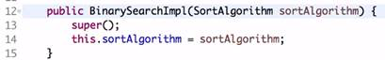

We could have done this with setter injection.

Right click, generate getters/setters

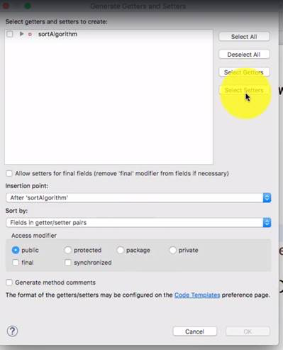

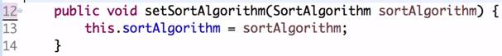

The log will look like this with setter injection



But you actually can not include an injection – just depend on @Autowired

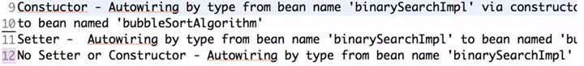

Used to say in earlier versions of Spring – all mandatory dependencies should use constructor injection

sortAlgorithm is a mandatory dependency – without it the binary search can’t work. If the class can still run without a dependency, those dependencies are optional.

For all non-mandatory (optional) dependencies, use setter injection

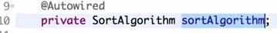

But these days, just use @Autowired – so you don’t need to create a constructor

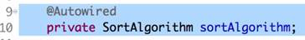

Now – there isn’t much difference between using constructor or setter injection – pick either one

Lecture 20 – Spring Modules

Spring is built in a modular way – you can pick & choose modules to use

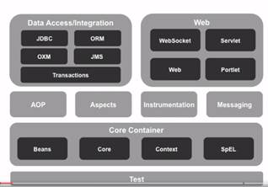

We have been using the Core container so far – Beans, Core, & Context

Data access = for databases

Spring JDBC – reduces a lot of lines of code

ORM – object relational mapping frameworks – Hybernate, myBatis

JMS – to talk to another application over a queue

OXM – object to XML transformation

Transaction management – all steps need to be successful or roll it back

Spring MVC – part of Web

Portlet – outdated

Now we talk about cross-cutting concerns – stuff that is applicable to more than 1 layer of an application – an example is unit testing – want to be able to test in the web layer, business layer, and the data layer

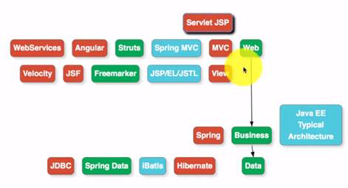

Spring has good support for unit testing through the Spring test framework

AOP – aspect oriented programming – security, logging

Aspects – advanced AOP

Lecture 21 – Spring projects

All the Spring modules have the same release version as the spring framework

Spring does other things besides Spring Framework & its modules, which are called Spring projects – these provide solutions to problems faced by enterprise applications

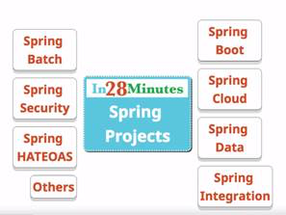

Spring Boot – once of the most popular frameworks to develop microservices today – easy & fast

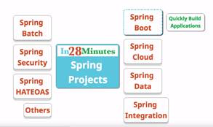

To developer Cloud native applications – to cloud enable the microservice you made with Spring Boot

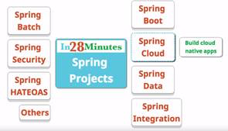

Spring Data – consistent data access – today we have a mix of data sources, SQL, noSQL – so this allows you to access data consistently

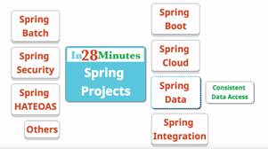

Spring integration – application integration – connecting enterprise applications easily

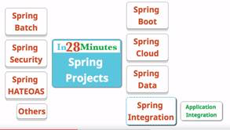

Spring batch – have their own requirements – developing batch applications easily – not all processing is done online – some of the processing is done in batch applications

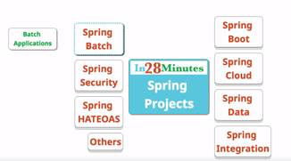

Spring security – securing web apps, REST services, multiple, oAuth

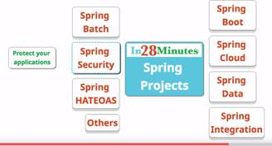

HATEOAS – in REST, don’t just want to return data – need to return the relevant links to help the consumer understand where to go next

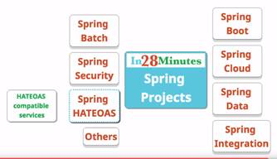

There are others – Spring webservices, session, social, mobile, Android

Lecture 22 – Spring popularity

Spring has retained relevance for many years

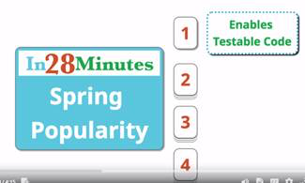

The core feature of Spring is dependency injection – allows us to write unit tests easily – good integration with jUnit & Mockito

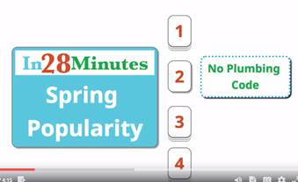

You don’t have to deal with exception handling

Without spring:

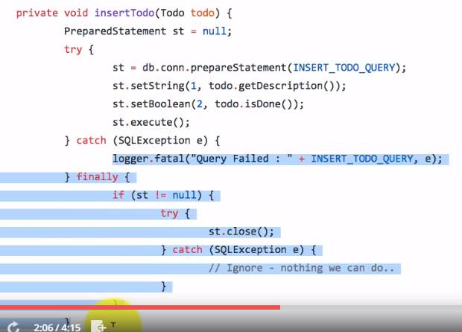

With Spring:

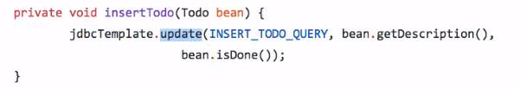

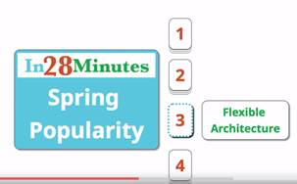

Spring is very modular – I can use a Spring module without using the others. Your options are not restricted – you can also use other frameworks along with it.

Struts is an MVC framework that Spring offers support for – even though it has its own MVC framework, Spring MVC

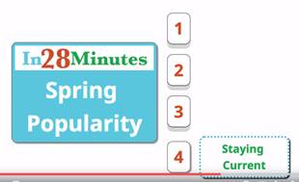

Section 2 – Lecture 22 – Spring Boot

Spring Boot is the most popular framework to develop microservices

Code is in Github – Springboot-in-10-steps

Lecture 23

@Component = this is a bean

@Autowired = this is a dependency

 Instead of building a huge application, we make several microservices - we want to build them quickly

Spring boot is #1 for developing Java micro services

Goals of Spring boot

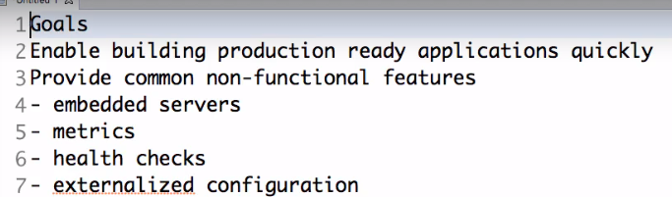

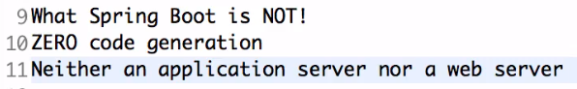

It does not generate code, and it's not a server (but it works well with servers)

Most important part of Spring Boot is Starter projects

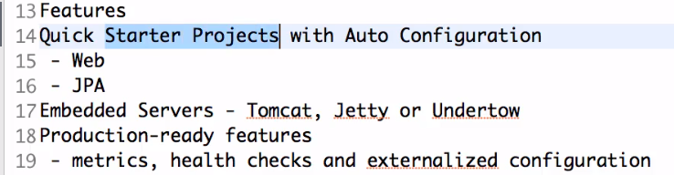

if I'm using Spring MVC, need to configure

dispatcher servlet

view resolver

with Spring Boot starter project just need to add starter called Spring boot starter web

automatically get

Spring MVC

Spring core

validation framework

logging framework

There's also a Spring Boot Starter JPA

-------

If developing web application & want to deploy on Linux box

In olden days, need to install:

Linux box

java

web server (Tomcat, weblogic or websphere)

deploy application war

With Spring Boot, we get embedded server

package your server - package Tomcat with application jar

don't need to install on Linux box

Spring Boot actuator = monitoring for application - how many times a service is called, failed, if running

Externalized configuration

Configuration varies between different environments - dev is different than production

In Spring boot, can create property files with a naming convention & that's it

Also support for different profiles

Lecture 25 - Developing Applications before Spring Boot

If not using spring boot - you really needed to decide what frameworks, dependencies/versions to use, had to implement default exception handling, create spring configuration file

But spring boot will provide all this for us - so you can concentrate on business logic

 Dispatcher servlet?

Lecture 26 - Using Spring Initializer

Start.spring.io

To be able to develop a REST service, need web starter

When you import into Eclipse, it will start downloading dependencies

Lecture 27 - Creating a Simple REST Controller (Service)

Make a new class (a bean)

Make a constructor

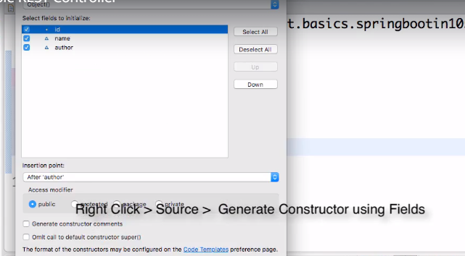

Generate getters (can also do setters)

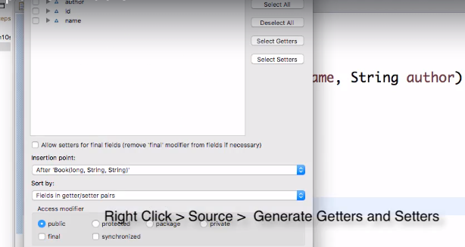

Generate to String

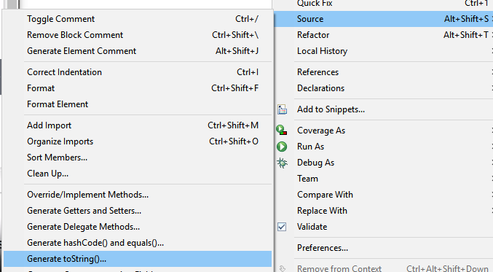

Then start creating the REST controller

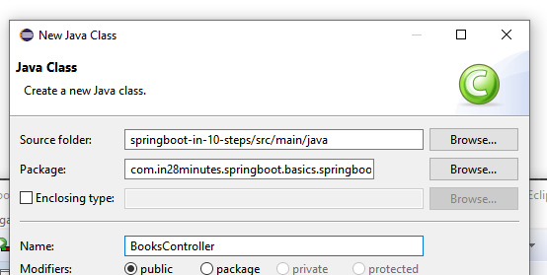

Have to add @RestController

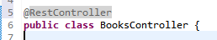

Now map a URI to it

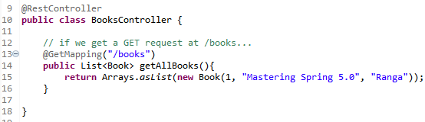

Server is going to respond with JSON response

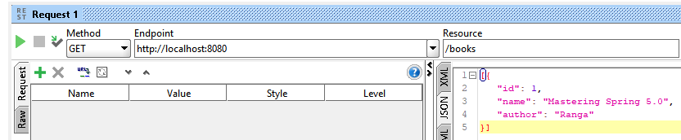

We didn't have to think about infrastructure - configuring framework/beans/dispatcher servlet/view resolver

Lecture 28 - Spring Boot Auto Configuration

 What exactly is a pull request…

 Print/send to self the notebook where I did the other tutorials

@SpingBootApplication - this is a Spring context file, enables autoconfiguration, enables component scan

Component scan - auto scan the package for any beans (classes) to be managed by the Spring framework

SpringApplication.run is used to run a Spring context - the input is the Spring context

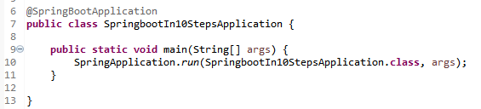

The run method returns an Application Context

You can print out all of the beans that are being autoconfigured

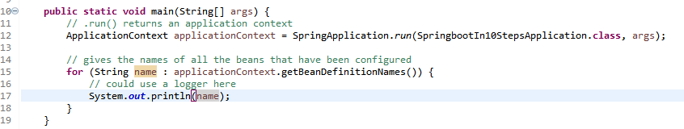

Autoconfigure is imported by Maven

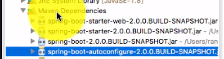

The autoconfiguration classes are creating the beans

"Spring web mvc is on the 'classpath'" so Spring knows that it needs to configure a dispatcher servlet, view resolver

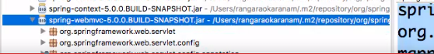

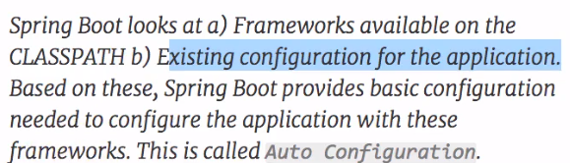

So if you're using a web starter, you need a dispatcher servlet, internalization, messaging - all of this autoconfigured for you

For example, the DatasourceAutoConfiguration bean will only be created if these are on the classpath:



Another example - only created if no beans of type DataSource.class are on the classpath

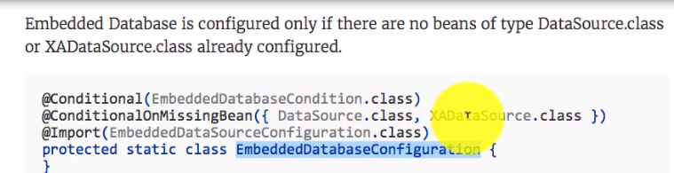

If you want to see more, turn on Debug logging

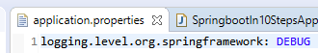

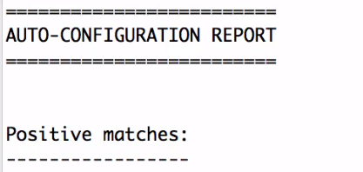

Positive matches - means I found something of this kind on the classpath - so I've configured this automatically

Jackson is for binding

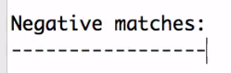

Negative matches - things that were not autoconfigured - beans for these were not created

Lecture 29 - Spring Boot vs. Spring vs. Spring MVC

Spring - takes care of beans & dependencies, @. Helps you build loosely coupled applications - easily unit tested.

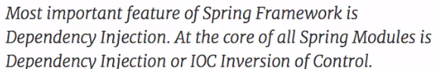

This is tightly coupled - the WelcomeController is tightly coupled to the WelcomeService

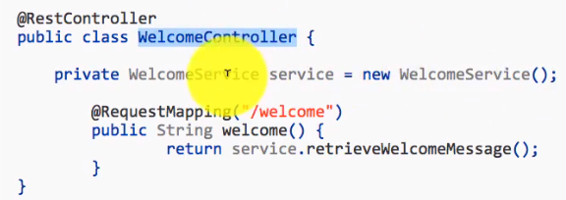

But if you use Spring & use dependency injection (@Autowired)

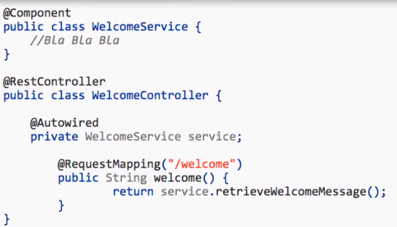

You can use frameworks like Mockito and Mock Spring MVC to replace this service with a mock and unit test

It also solves duplication/plumbing code - when you use Spring JDBC, Spring MVC, etc.

Boilerplate code - try catch, exception

Also provides good integration with other frameworks

Spring MVC

For developing web applications

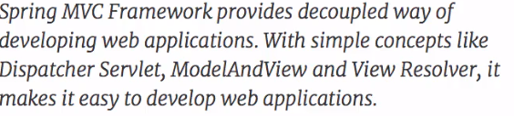

Spring Boot

Autoconfiguration - sort of sets stuff up for you - and gets that stuff the stuff it needs to work

Looks at the classpath - and provides automatic configuration

Starter projects

Monitoring features - actuator, logging

---

From another tutorial:

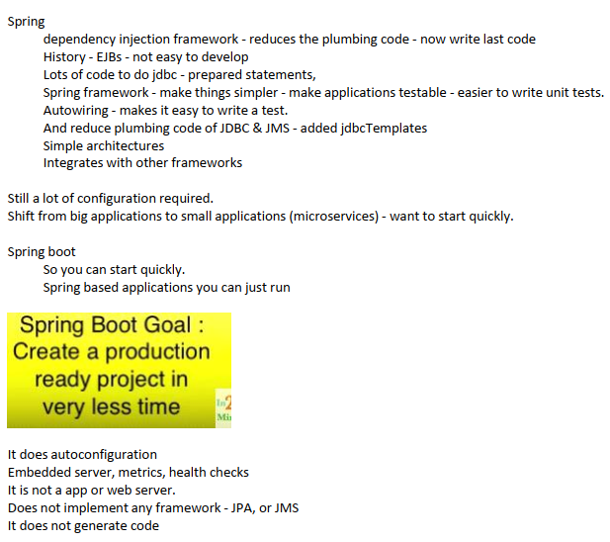

Lecture 30 - Starter Web & Starter JPA

Spring boot starter web is good for developing web applications & REST services

If you hold control & click:

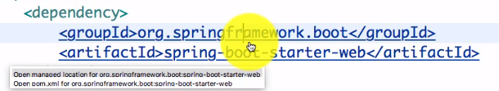

You can see that it's already set up Tomcat - this is how we automatically get Tomcat

You get Spring web, Spring MVC, hibernate-validator, starter-json (more for REST web services) - automatically allows us to convert to JSON format

 What is validation?

After it brings in all the dependencies - autoconfiguration kicks in.

Springboot starter tests - to write unit & integration tests - gets you jUnit, Mockito,

 What are unit/integration tests?

Springboot starter JPA

JPA is the interface for Hibernate - defines how ORM (object relational mapping) applications work

Don’t worry if it doesn't make sense yet



Lecture 31 - Overview of Starter Projects

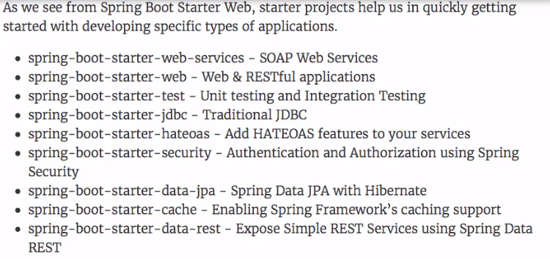

Spring boot starter web services - for SOAP, WSDL

 HATEOAS

Security - oAuth

 JPA, Hibernate

Cache - for caching

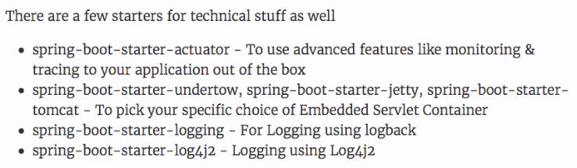

If you have a problem to solve, see if there is a starter that can solve it

Lecture 32 - Spring Boot Actuator

Add to pom.xml

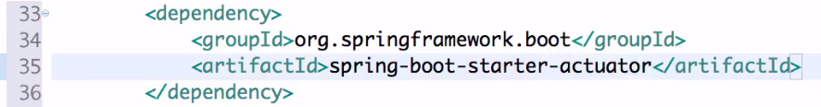

Actuator - monitoring. Read metadata about the application, the beans that are autoconfigured, how autoconfiguration has worked, how many times a service is called, how many times a service has failed

Use a hal browser

Hal is a standard

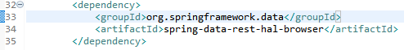

Once you add & save, you can see the jars show up under the Maven Dependencies folder

Go to localhost:8080/actuator

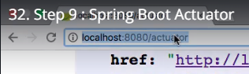

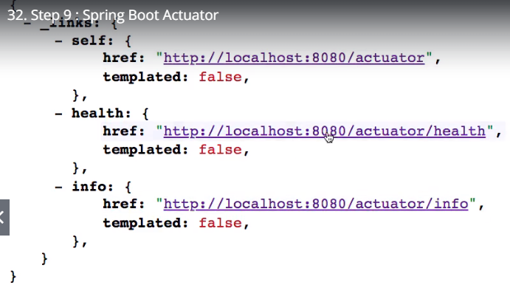

Can click on these links

Add to application.properties



Then go to localhost:8080 - to get to the HAL browser - can use to browse through the actuators

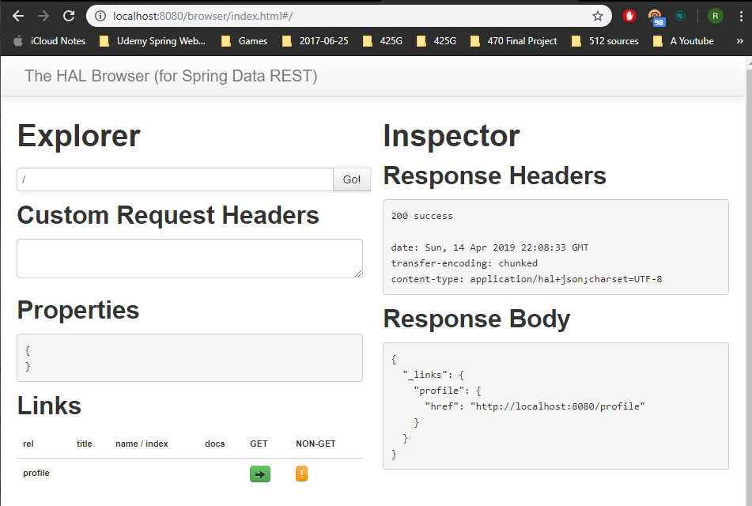

If you type in:

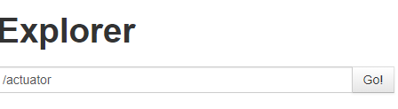

Can look through.

Auditevents = which users properly validated, how many people failed authenticaion

Beans = all the spring beans that are configured - that spring has created for you

Health = up or not

Conditions = positive matches, negative matches - which beans are configured and which aren't

Metrics = you can use any of the "names" in the Response Body and append to the URL to see info

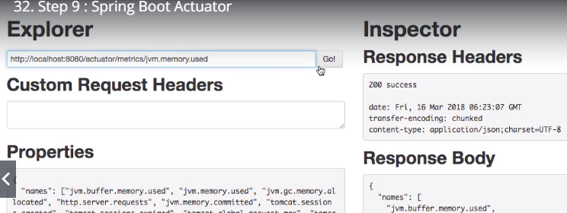

Result:

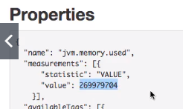

HttpTrace = all the requests that were executed

You don't want to have the actuator on in production because it will cause a performance impact

Mappings = all the things that are mapped to URIs

Lecture 33 - Spring Boot Developer Tools

When we make a change, we want the server to be reloaded automatically - add Spring-boot-devtools to pom

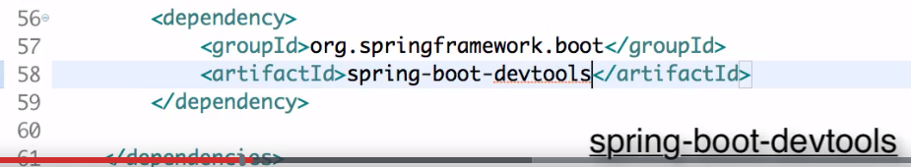

<dependency>

<groupId>org.springframework.boot</groupId>

<artifactId>spring-boot-devtools</artifactId>

</dependency>

Looks like you can also include this when you initialize

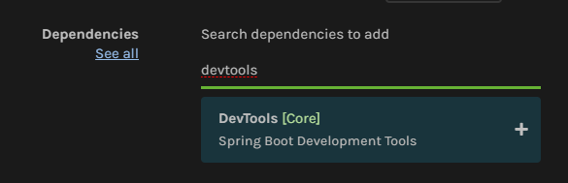

A fresh restart takes longer - using devtools will make it faster - it knows Maven dependencies won't change so it doesn't load the things that are dependent on these again

It only reloads the application beans again - only the things that are application related

Next Section - SOAP

Lecture 34 - SOAP Overview

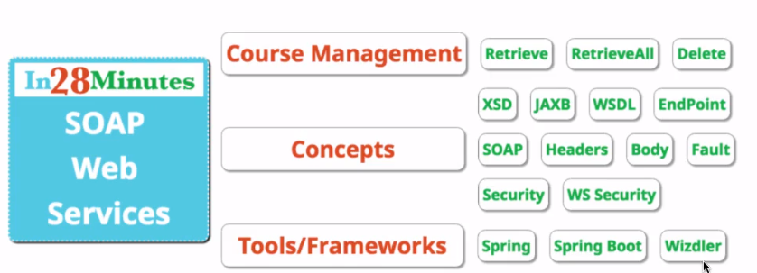

Lecture 35 - Initialize a Web Services application using Spring Boot

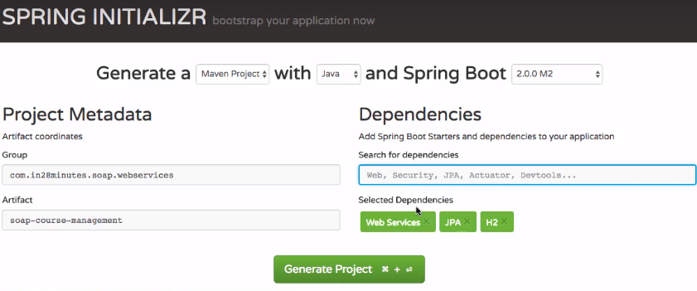

Web Services = for SOAP

JPA = to persist data in SQL stores

H2 = in memory database

This is the most important dependency - spring web services



Lecture 36 - Overview of creating SOAP web service using contract first approach

Spring web services has a contract first approach - define the format of the request & response before developing the web service

XSD - XML schema definition

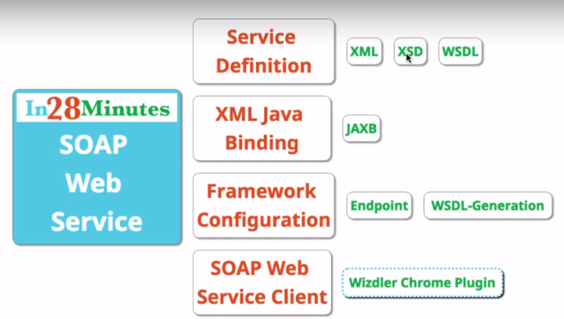

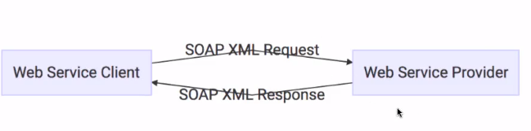

We want to create a web service provider

Example request:

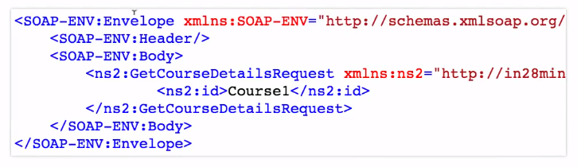

The header is optional

We going to get details for a specific course

Example response:

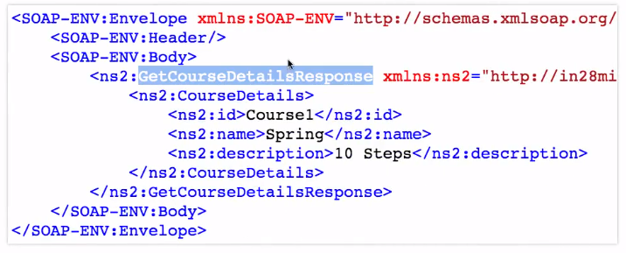

We define the structure of how the request & response should look

Then we define an XSD - how the request/response should look

Then generate WSDL - it will be generated for us

JAXB - a Maven plugin - Java API XML Binding - the XML that comes into the provider needs to get converted to an object (because this is a Java application). Then for the response, the object needs to get converted to XML. This is where XML binding comes in. JAXB will take the XSDs and generate Java objects.

Endpoints - process the request - have all the business logic - and create the response

WSDL-Generation

We will use a Chrome plugin called Wizdler

Lecture 37 - Define Request/Response XML Structure

Need to define what a request will look like - want to get details for a specific course

Send in an id, receive the details of the course in the response

(print)

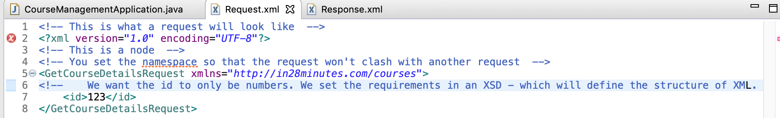

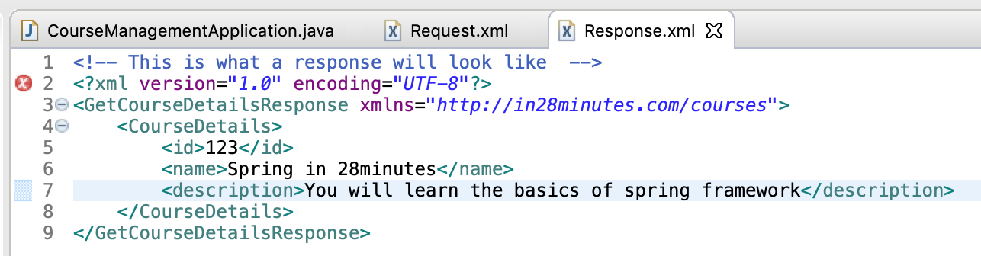

Lecture 38 – Define XML Schema Definition (XSD) for Request

XSD helps define whether our requests are fine or not

XSD defines what XML should look like

To make an XSD:

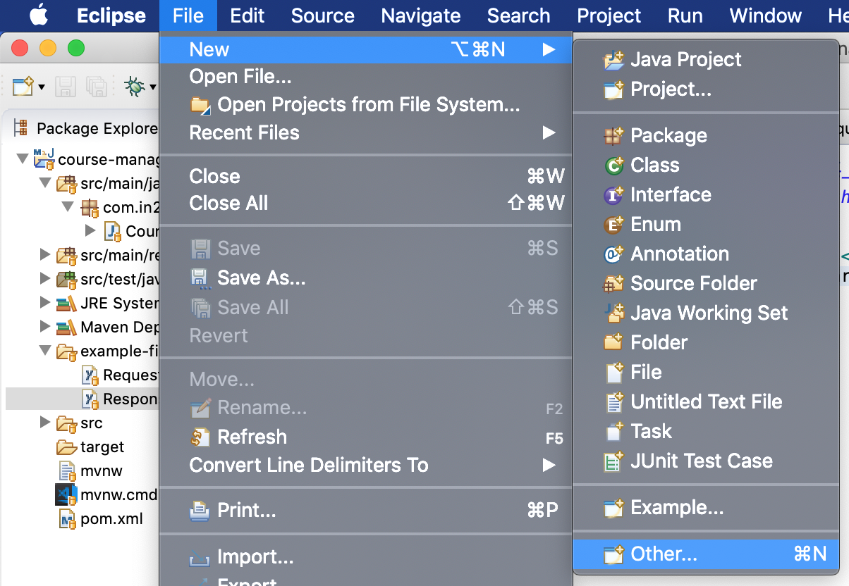

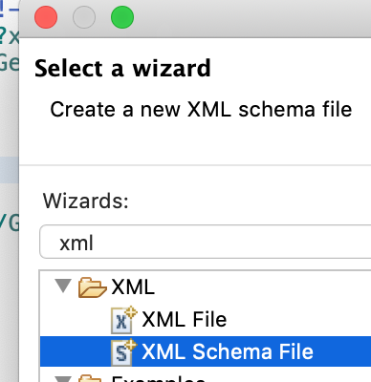

The XSD defines that there would be a get course details request

with an element called ID

which is of the type integer

Use the XSD to determine if requests are valid

Can be shared in WSDL for customer to understand how to create XML requests – the XSD is a communication between the service provider & consumer – you can look at the XSD and know what things should look like

Lecture 39 – Define XML Schema Definition (XSD) for Response

See the code for what we added

Lecture 40 – More about XML Schema Definition and Implementing XSD Best Practices

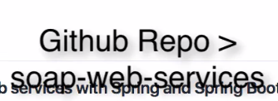

Lots of things that go into XML – look at this website

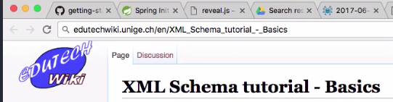

There are several other things you can check – currency (dollars, euros, etc.)

Namespace

- if you don’t specify one, whatever you put after xmlns is the default namespace – but this is not really a good practice



So we add the prefix xs



You have to add this to all of the lines – even the types

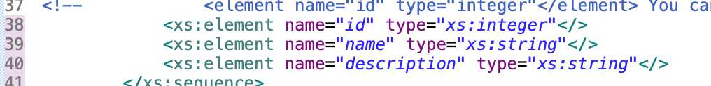

need to start making use of these XSD in our project

map Java objects to be able to create the XML that is defined in this XSD

start doing some binding

Lecture 41 - Introduction to Java API for XML Binding (JAXB) and Configuring JAXB 2

We defined the XSD

Now we want to use the XSD

We want to map our java objects – so they can generate the XML which is defined in the XSD

We will get SOAP XML as input – Then need to convert it to Java

Then convert the response from Java to SOAP XML – will use JAXB to do that

JAXB will look at the XSD file and create Java objects

Need to copy the course-details.xsd to the src/main/resources folder

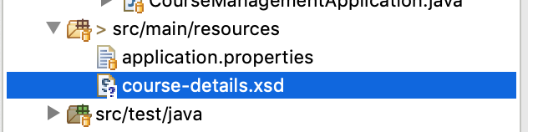

We need to configure JAXB Maven plugin – we will define it in pom.xml – it will look at the resources folder for XSDs – and it will create the Java objects based on the XSD files in src/main/java

Going to pull in JAXB2 – from Googleing

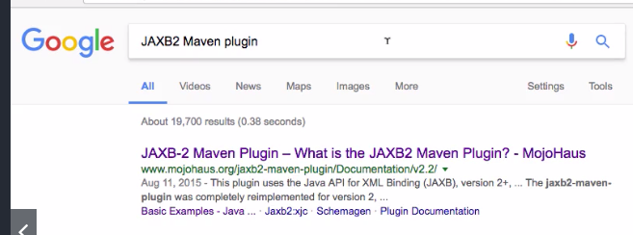

Use xjc

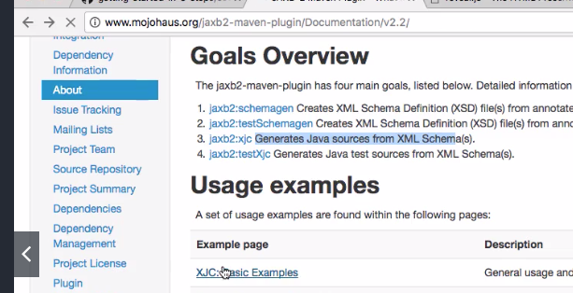

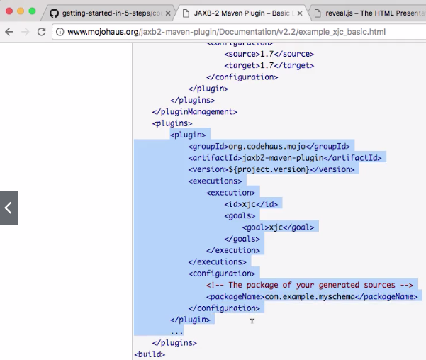

Troubleshooting Tips

